BABA GANOUSH

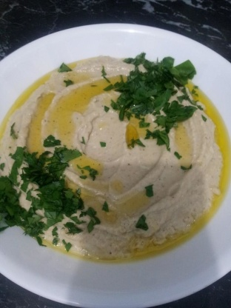

INGREDIENTS
- 1 large eggplant
1⁄4 cup tahini, plus more as needed
- 3 garlic cloves, minced
1⁄4 cup fresh lemon juice, plus more as needed
- 1 pinch ground cumin
- salt, to taste
- 1 Tablespoon extra virgin olive oil
- 1 Tablespoon chopped fresh flat-leaf parsley

Serve with pita bread and 1⁄4 cup black kalamata olives.

METHOD

- 1. Preheat an oven to 200°C.
- 2. Cut eggplant in half. Place cut side down onto baking paper, place on a baking tray and roast for 20 minutes or until soft.
  - 3. Remove from the oven, let cool slightly, and peel off and discard the skin.
- 4. Place the eggplant flesh in a bowl or food processor.
- Mash the eggplant to a paste.
- 5. Add the 1/4 cup tahini, the garlic, the 1/4 cup lemon juice and the cumin and mix well. Season with salt, then taste and add more tahini and/or lemon juice, if needed.
- 6. Transfer the mixture to a serving bowl and spread with the back of a spoon to form a shallow well. Drizzle the olive oil over the top and sprinkle with the parsley.
- 7. Place the olives around the sides. Serve at room temperature.

